In the simulation, there are multiple POIs distributed in the area, and to verify the performance of the algorithm, we set the number of POIs to 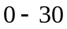. The height of POIs is set to 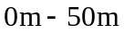, and the sweep period of POIs is set to . The description of the parameters of POIs is as follows.
In practice, for example, in monitoring forest fires, we can observe significant differences in vegetation density and the number of combustible points in different regions. To simulate this diversity in the simulation model and optimize the monitoring strategy, we designed two areas: one with a dense distribution of POIs and the other with a sparse or single POI.
Dense POI areas: namely, high-density areas. For example, the fire risk is higher in areas with dense trees and more flammable point. Therefore, we set up a dense POI in the simulation, whose coordinates are arranged relatively close together and the sweep period relatively small compared to the low-density areas. This design allows us to sweep these areas frequently and detect early signs of fire in time, improving response speed and firefighting efficiency.
Single POI areas: namely, low-density areas. They have sparse trees, fewer flammable points, and lower fire risk than high-density areas. In these regions, we set up a single or fewer POI whose coordinates are arranged more widely in the simulation, and the sweep period is larger. This design reflects the lower monitoring frequency and fire risk, ensuring the proper allocation of monitoring resources.
With this differentiated POI setup and coordinate arrangement, we can simulate the actual monitoring needs of different areas and optimize the allocation of monitoring resources. The description of the POIs’ height and sweep period is as follows:
- The POIs’ height: In reality, the height of a small hill could be 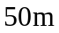. The height of a mountain slope can vary due to factors such as geographical location and terrain. The mountain slopes may only be a few meters high in some areas. While in others, they may reach several hundred meters or even higher. Therefore, setting the POIs’ height to is reasonable.
- The sweep period of POIs: In [Ref 1], the required coverage time interval of each POI is randomly distributed in 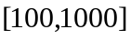 seconds. Therefore, it is reasonable to set the sweep period of POIs to in the simulation.

REFERENCES
[Ref 1] P. Huang, F. Lin, C. Liu, J. Gao, J.-l. Zhou, “ACO-based sweep coverage scheme in wireless sensor networks,” Journal of Sensors, vol. 2015, pp. 1-6, Feb. 2015.

There are five scenarios; each scenario has six charts shown below, which are distinguished based on the number of POIs: 5, 10, 15, 20, 25, and 30. The coordinates of POIs are marked at the top of each chart, and these coordinates are arranged in the same order as the numbered POIs in the chart. Each chart corresponds to a specific sweep period set, labeled sequentially from Period 1 to Period 6. The order of elements within each set strictly matches the numbering order of the POIs in the charts, ensuring that the sweep period of each POI corresponds precisely to its identified position on the chart. The sweep period sets of the POIs are as follows:

Scenario 1
Period 1=[250; 260; 270; 500; 700]
Period 2=[250; 260; 270; 600; 700; 220; 200; 200; 220; 200]
Period 3=[250; 260; 270; 600; 700; 200; 200; 200; 220; 200; 200; 200; 200; 600; 220]
Period 4=[250; 260; 270; 600; 700; 220; 200; 200; 220; 200; 200; 200; 200; 600; 220; 400; 420; 600; 600; 200]
Period 5=[250; 260; 270; 600; 700; 220; 200; 200; 220; 200; 200; 200; 200; 600; 220; 400; 420; 600; 600; 200; 220; 210; 200; 220; 210]
Period 6=[550; 560; 570; 600; 700; 220; 200; 200; 220; 200; 300; 200; 200; 600; 320; 400; 420; 600; 600; 200; 220; 310; 400; 420; 410; 200; 210; 290; 320; 200]

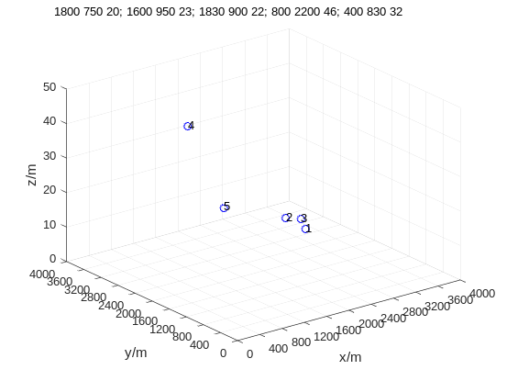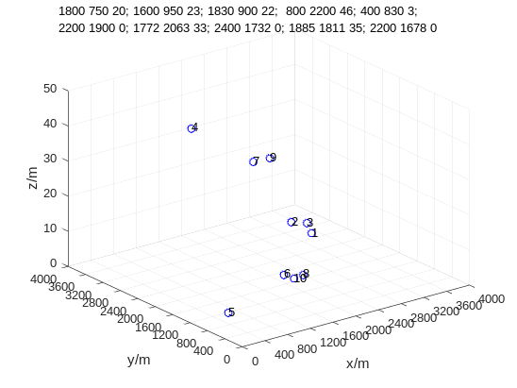

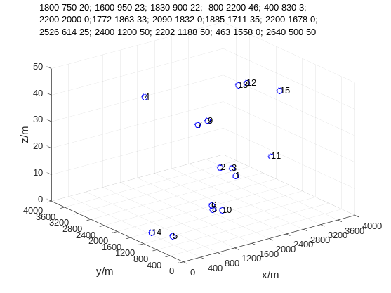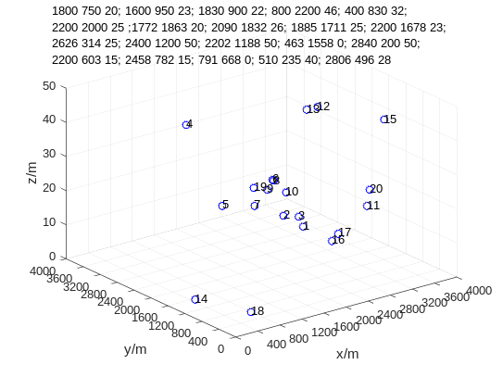
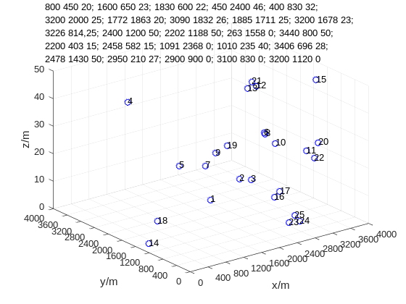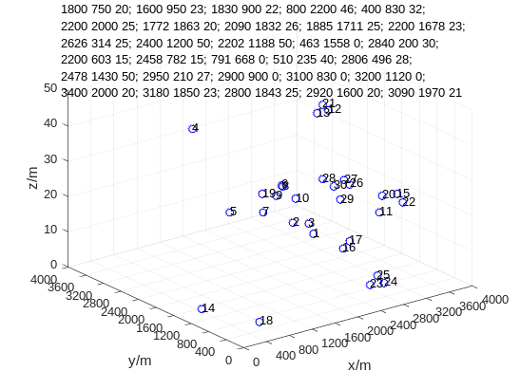

Scenario 2
Period 1=[250; 260; 270; 500; 700]
Period 2=[250; 260; 270; 600; 700; 220; 200; 200; 220; 200]
Period 3=[250; 260; 270; 600; 700; 220; 200; 200; 220; 200; 220; 200; 200; 600; 220]
Period 4=[250; 260; 270; 600; 700; 220; 200; 200; 220; 200; 220; 200; 200; 600; 220; 410; 430; 600; 600; 220; 220; 210; 200; 220; 210]
Period 5=[250; 260; 270; 600; 700; 220; 200; 200; 220; 200; 220; 200; 200; 600; 220; 210; 230; 600; 600; 220; 220; 210; 200; 220; 210]
Period 6=[250; 260; 270; 600; 700; 220; 200; 200; 220; 200; 220; 200; 200; 600; 220; 210; 230; 600; 600; 220; 220; 210; 200; 220; 210; 200; 210; 290; 320; 200]
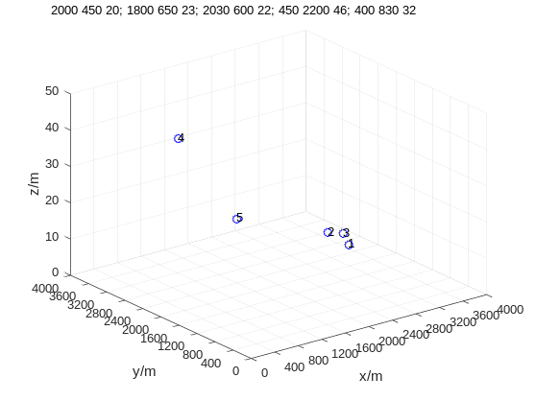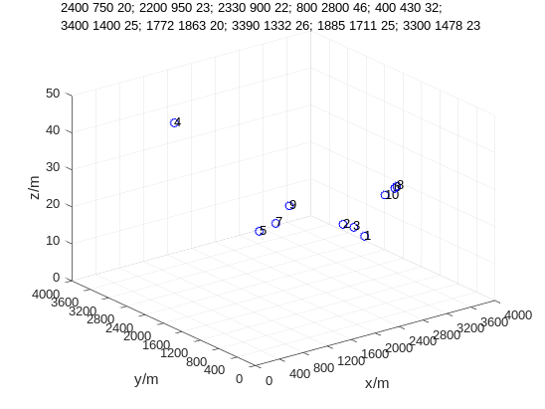
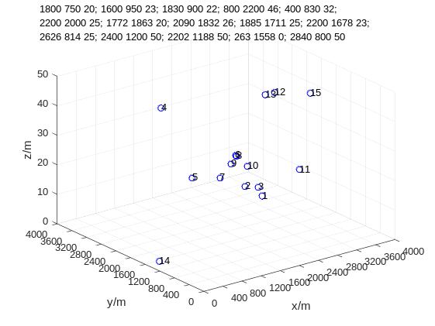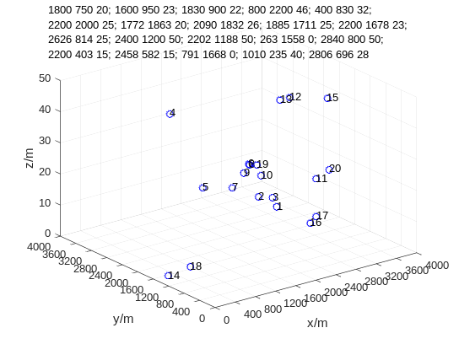
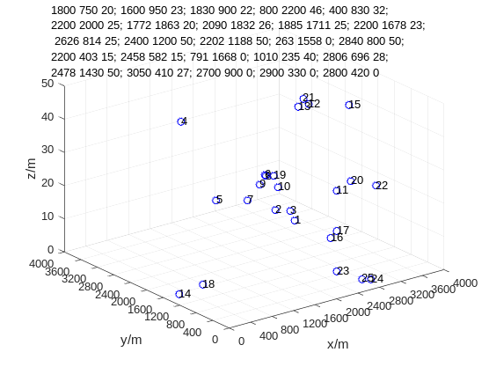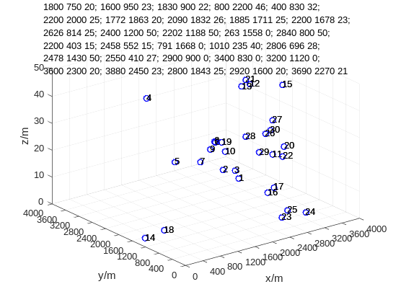
Scenario 3
Period 1=[230; 250; 240; 600; 700]
Period 2=[250; 260; 270; 600; 700; 220; 200; 200; 220; 200]
Period 3=[250; 260; 270; 600; 700; 220; 200; 200; 220; 200; 220; 200; 200; 600; 220]
Period 4=[250; 260; 270; 600; 700; 220; 200; 200; 220; 200; 220; 200; 200; 600; 220; 410; 430; 600; 600; 220]
Period 5=[250; 260; 270; 600; 700; 220; 200; 200; 220; 200; 220; 200; 200; 600; 220; 210; 230; 600; 600; 220; 220; 210; 200; 220; 210]
Period 6=[250; 260; 270; 600; 700; 220; 200; 200; 220; 200; 220; 200; 200; 600; 220; 210; 230; 600; 600; 220; 220; 210; 200; 220; 210; 230; 250; 220; 210; 500]
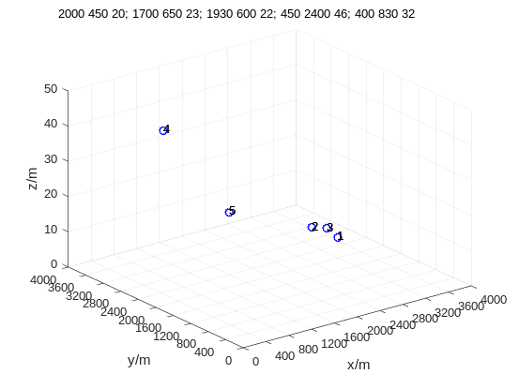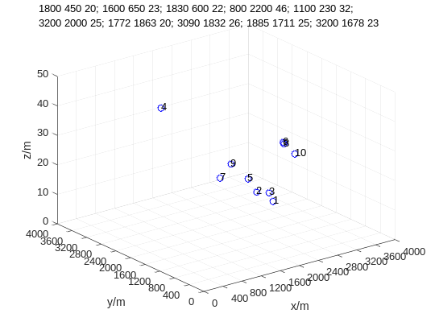
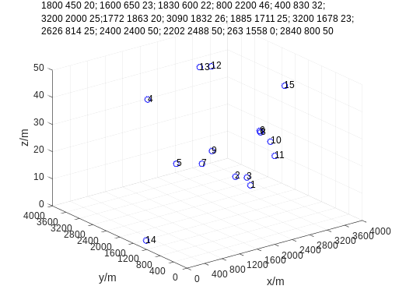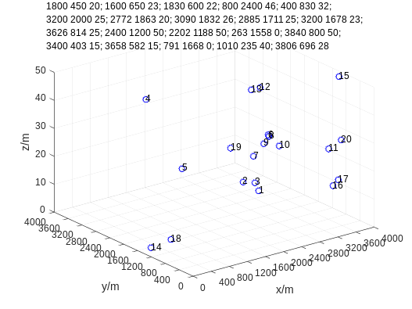
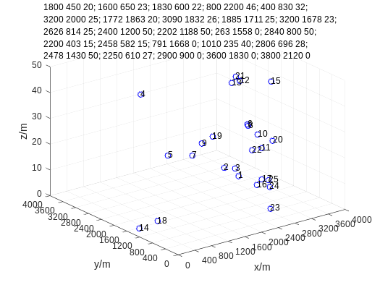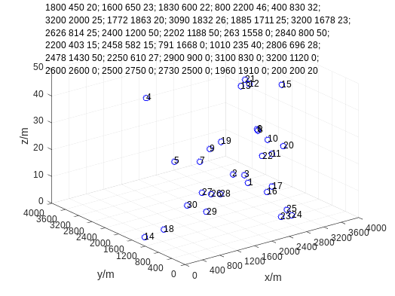

Scenario 4
Period 1=[250; 260; 270; 500; 700]
Period 2=[250; 260; 270; 500; 700; 220; 200; 200; 220; 200]
Period 3=[250; 260; 270; 500; 700; 220; 200; 200; 220; 200; 220; 200; 200; 600; 220]
Period 4=[250; 260; 270; 500; 700; 220; 200; 200; 220; 200; 220; 200; 200; 600; 220; 410; 430; 530; 600; 220]
Period 5=[250; 260; 270; 500; 700; 220; 200; 200; 220; 200; 220; 200; 200; 600; 220; 210; 230; 530; 600; 220; 220; 210; 200; 220; 210; 200; 210; 290; 320; 200]
Period 6=[550; 560; 570; 600; 700; 220; 200; 200; 220; 200; 300; 200; 200; 600; 320; 400; 420; 600; 600; 200; 220; 420; 400; 420; 410; 230; 220; 210; 550; 600]
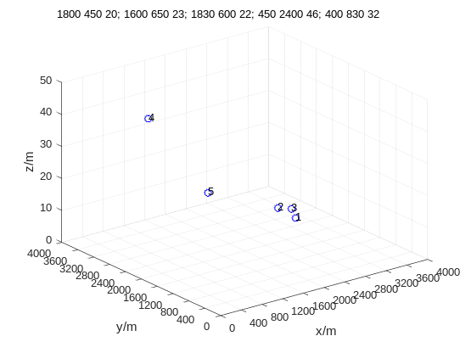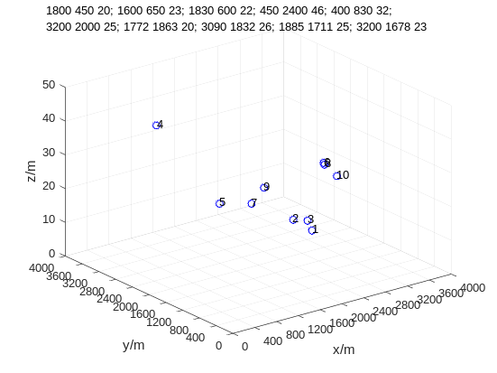
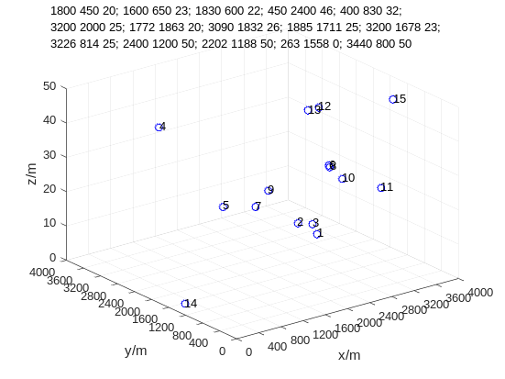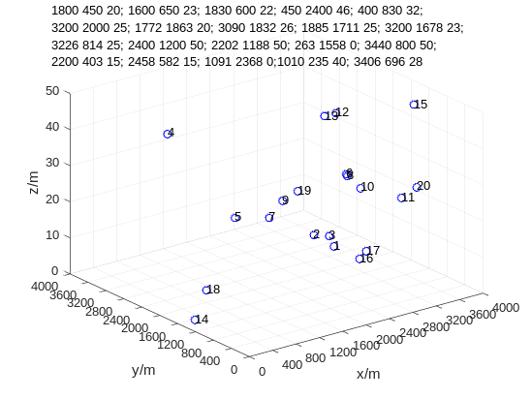
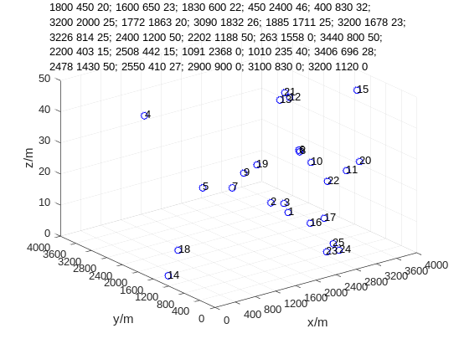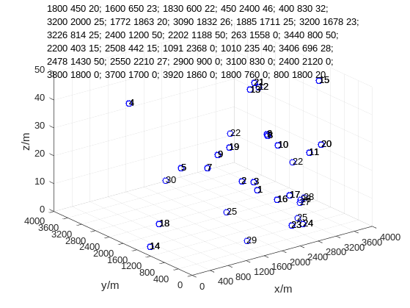

Scenario 5
Period 1=[250; 260; 230; 400; 720]
Period 2=[250; 260; 270; 600; 700; 220; 200; 200; 220; 200]
Period 3=[250; 260; 270; 500; 700; 220; 200; 200; 220; 200; 220; 200; 200; 600; 220]
Period 4=[250; 260; 270; 500; 700; 220; 200; 200; 220; 200; 220; 200; 200; 600; 220; 410; 430; 530; 600; 220]
Period 5=[250; 260; 270; 500; 700; 220; 200; 200; 220; 200; 220; 200; 200; 600; 220; 210; 230; 530; 600; 220; 220; 210; 200; 220; 210 ]
Period 6=[250; 260; 270; 500; 700; 220; 200; 200; 220; 200; 220; 200; 200; 600; 220; 210; 230; 530; 600; 220; 220; 210; 200; 220; 210; 200; 210; 290; 320; 200]
